9 unknown variables -:

1. Biomass concentration X=f (X, S, CL, H, T, Specific growth rate Mu = f(S, CL, X)
2. Substrate concentration S=f (X, S, CL, H, T)
3. Dissolved oxygen CL=f (X, S, CL, H, T)
4. Penicillin concentration P=f (X, S, CL, H, T, P)
5. CO2 concentration CO2=f (X, H, T)
6. Culture Volume V = f(T)
7. Hydrogen ion concentration H=f (X, H, T)
8. Heat of reaction QRXN=f(...)
9. Temperature T=f(...)

We have 9 ordinary differential equations and one non-linear algebraic equation (for specific growth rate mu) below:

1. Biomass X growth

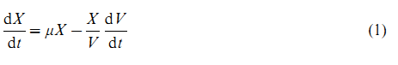

Where specific growth mu is given by Eq(3)

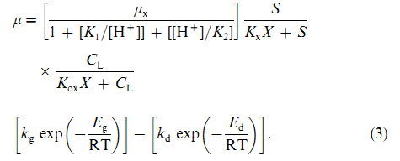

Eq(3) is used to calculate the RHS of ODE (1)

1. Hydrogen ion concentration H

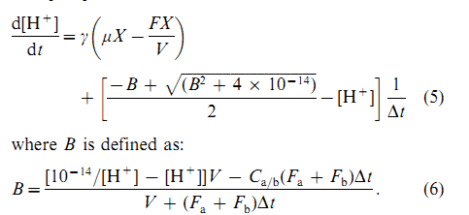

1. Penicillin P concentration

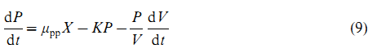

Where

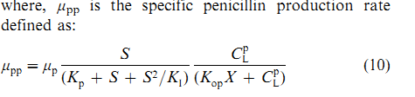

1. Substrate S

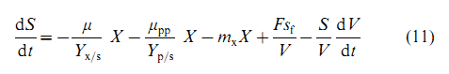

1. Concentration of Dissolved oxygen CL

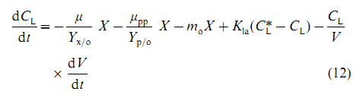

1. Volume of culture in fermentor V

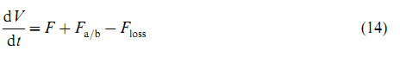



1. Heat of reaction

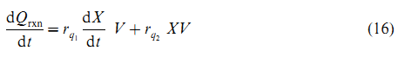

1. Temperature T

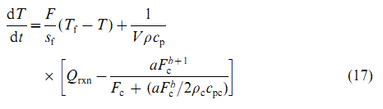

1. CO2 concentration

